User manual
On Web District GIS Parakh
for Indore Inspection Forms
Step 1: Open UAT URL of District GIS Parakh
https://gisuat.mp.gov.in/parakhweb/
or
Open PROD URL of District GIS Parakh
https://geoportal.mp.gov.in/parakhweb/
Step 2: Click on Department Icon
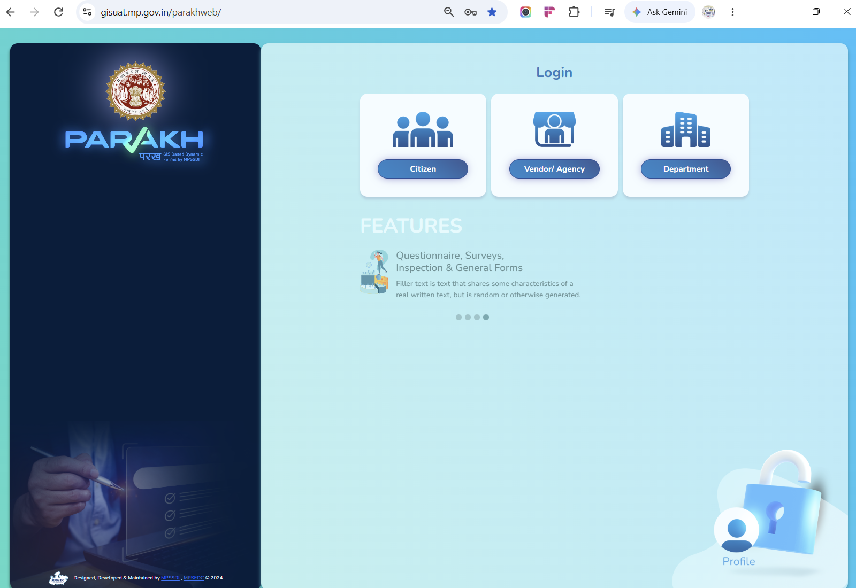
Step 3: Use Below Credentials :
Username: indorecollectorateadmin
Password: Test@123
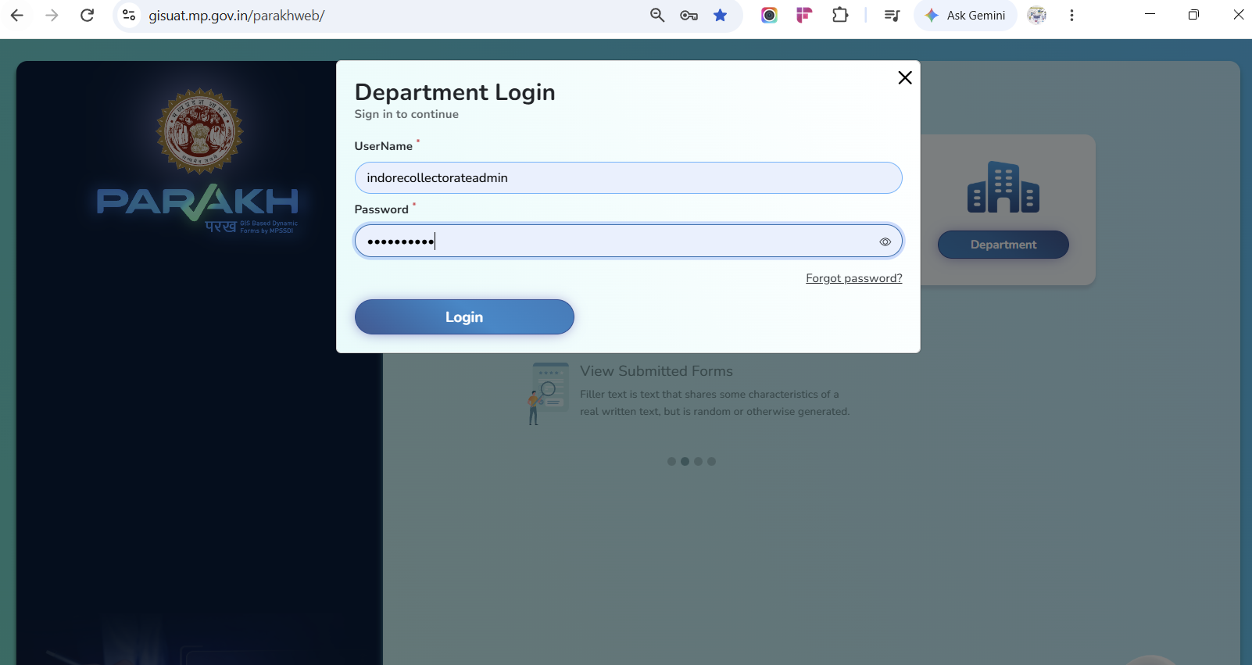
Step 4: Indore Collectorate admin home page
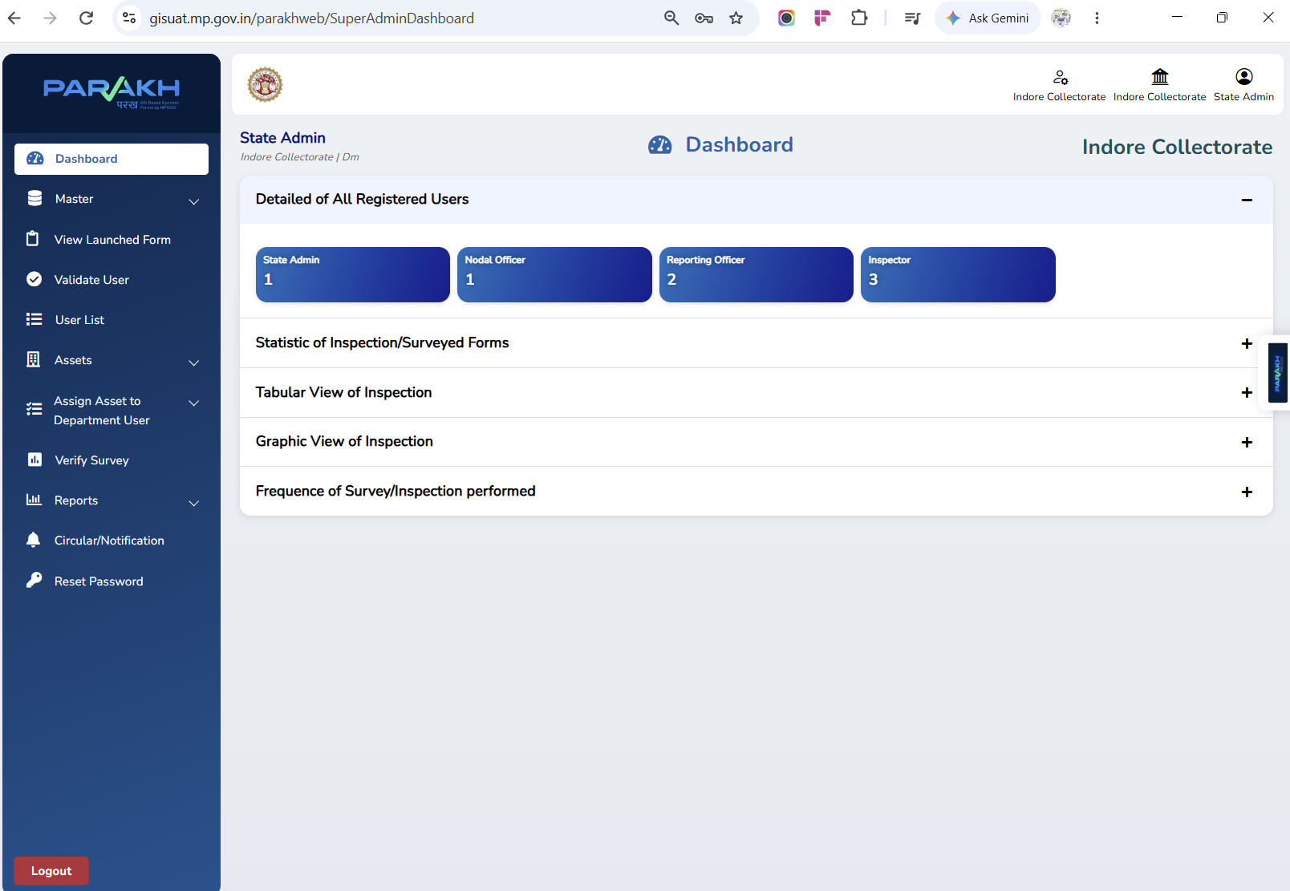
Step 5: RO Reporting Officer created
Check User inside <<USER LIST>> <<DepartmentName>><<UserType>>
and Create User inside <<MASTER>> <<CREATE USER>>
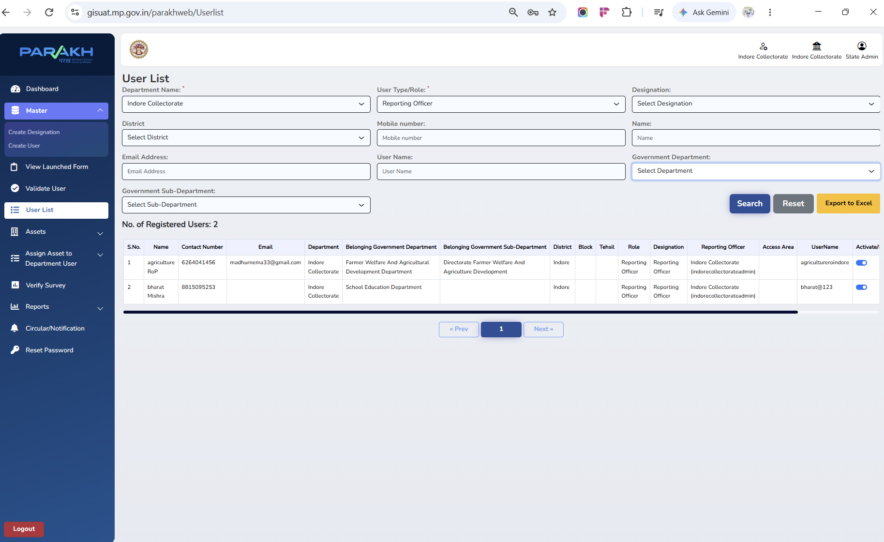
Step 6: RO User Created as Department HOD
Reporting Officer mapped to Department & Sub-Department in PARAKH Master

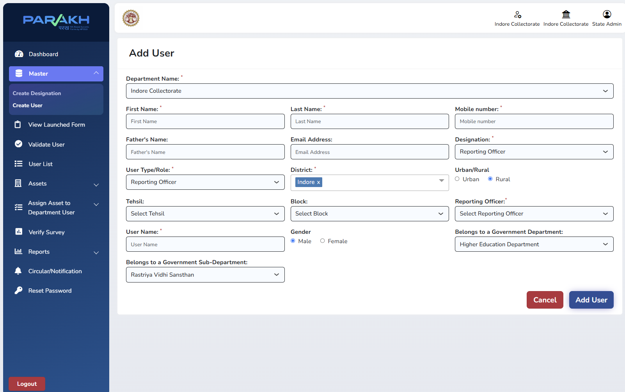
Step 7: Check - Department HODs Visible in User List
Admin can search, verify and export all Reporting Officers created
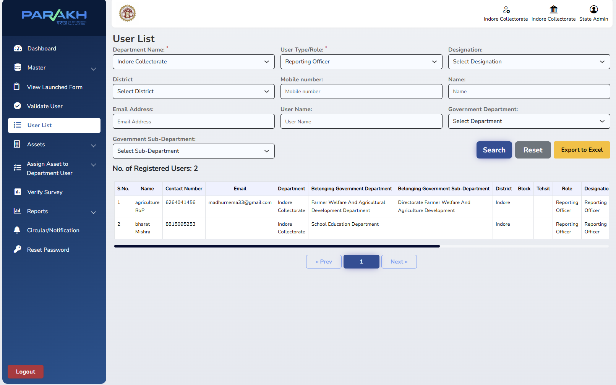
Step 8: Login through RO - (For Example: RO of Agriculture department)
UserName: agricultureoindore
Password: Test@123
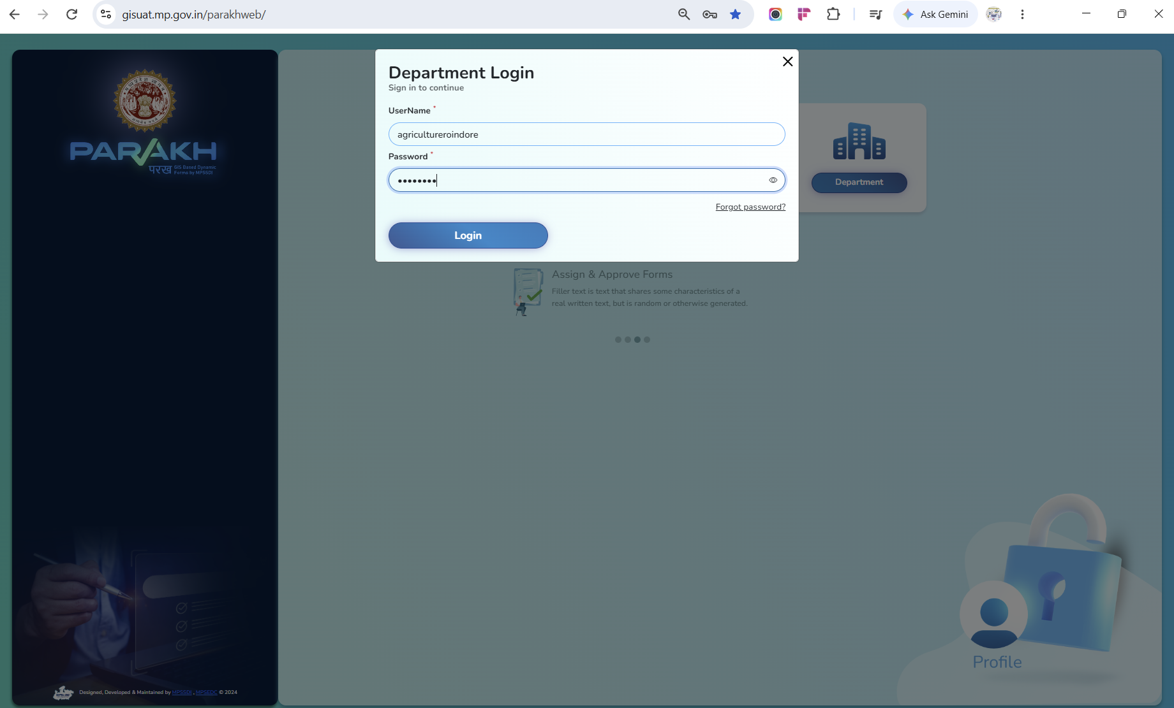
Step 9: Create Inspector User / Surveyor for Inspection under Department and Sub Department
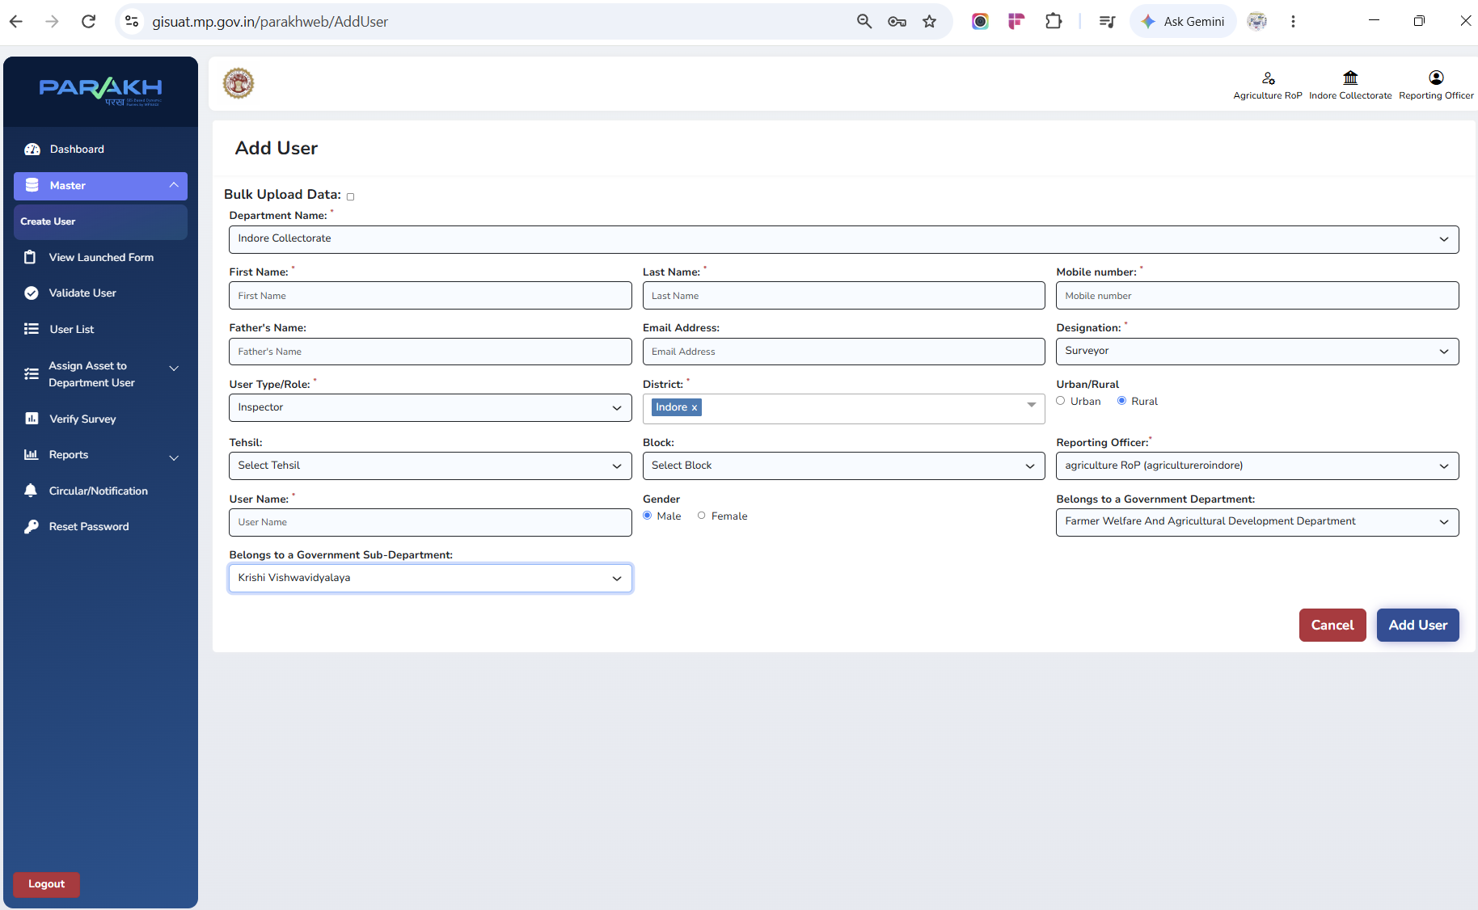

Step 10: Select specific form under <<View launched Form>>
and Work is going on for other remaining 17 forms which are Department specific
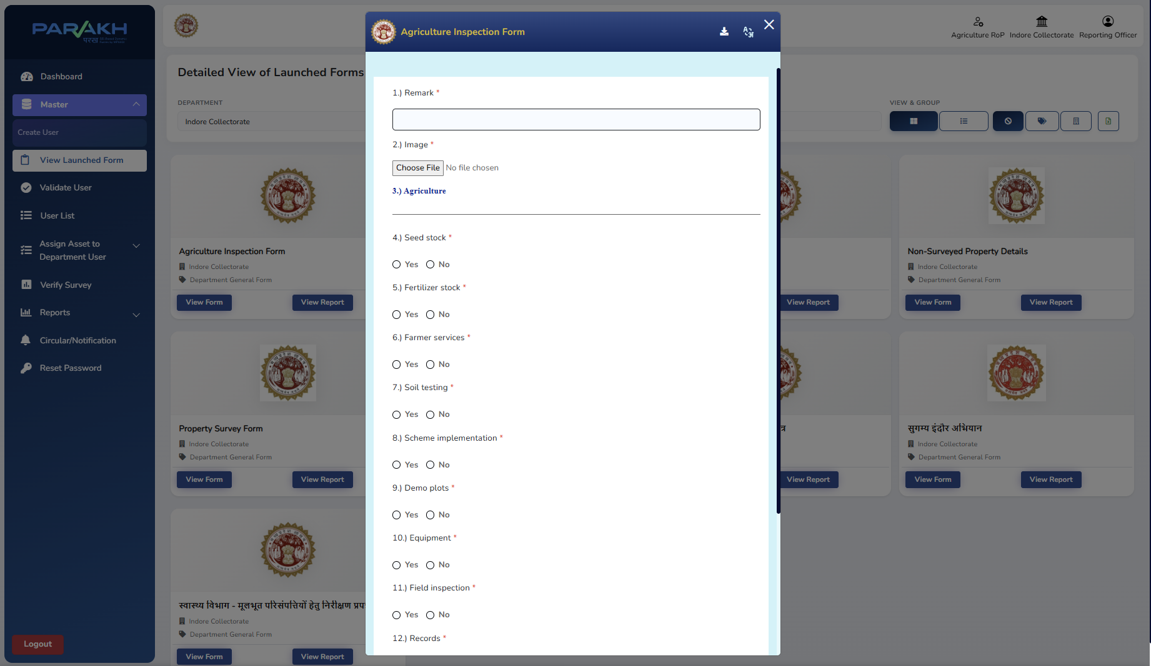
Step 11: Check which all users/inspectors/surveyor are created:
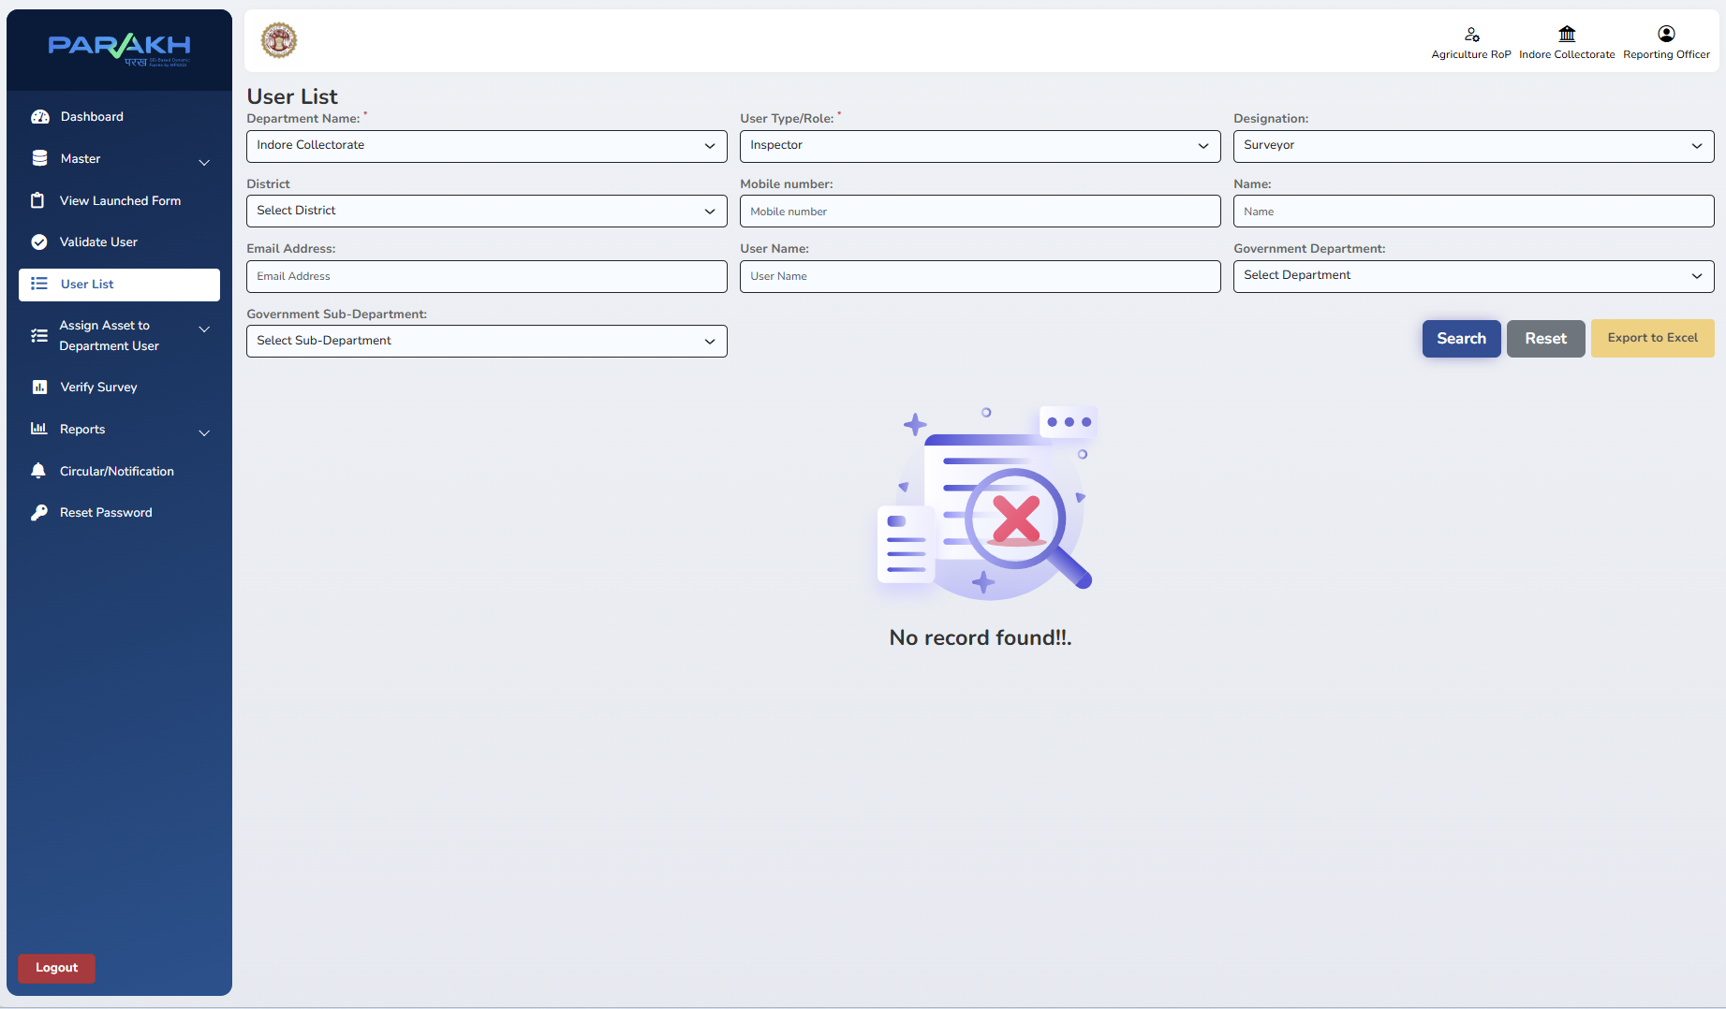
Step 12: Under <<REPORT>> check for <<GENERAL REPORT FORM>> Select Report for a Specific Form Name
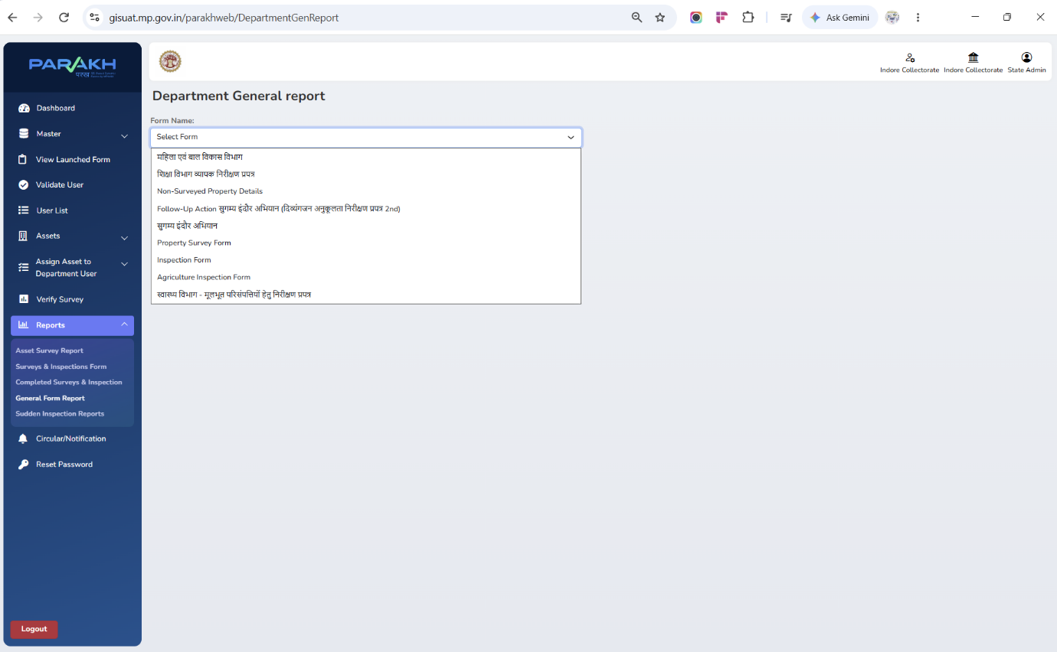
Step 13: Let suppose I opt for <<Shiksha Vibhag Nirikshan Prapatra>>
General Form Report — Reviewed & Actioned by HOD
Department HOD (RO) views submissions and takes action in one screen - Action Button Verify Inspection Status Verified by checker Reject and IN Progress or Pending
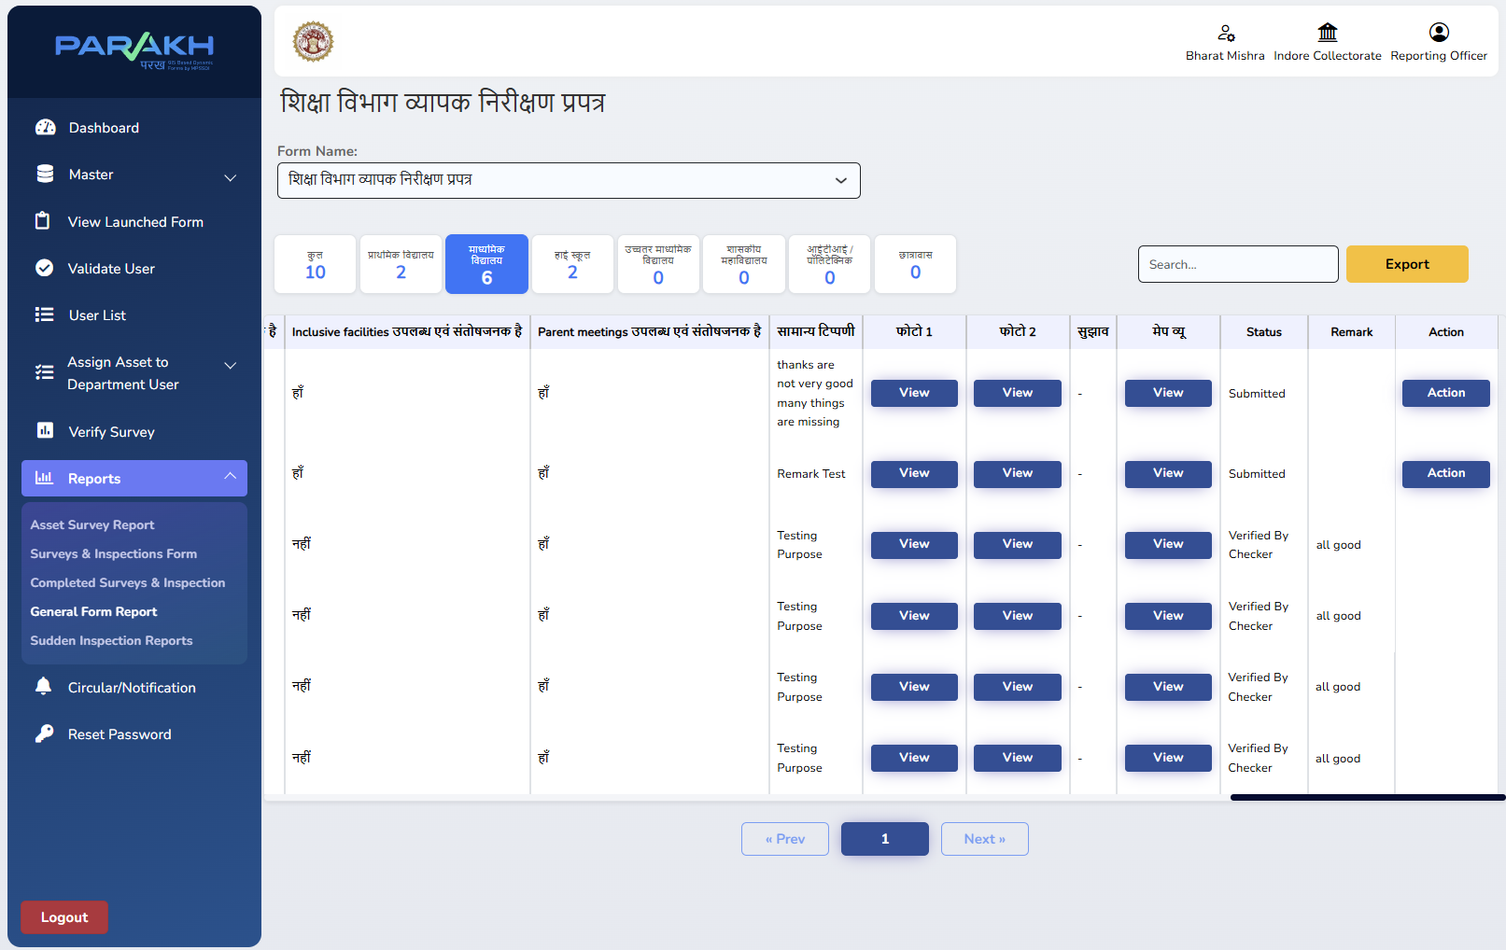
Action will be taken by RO of Department
While clicking on Action Button a Pop Up Message will come up :
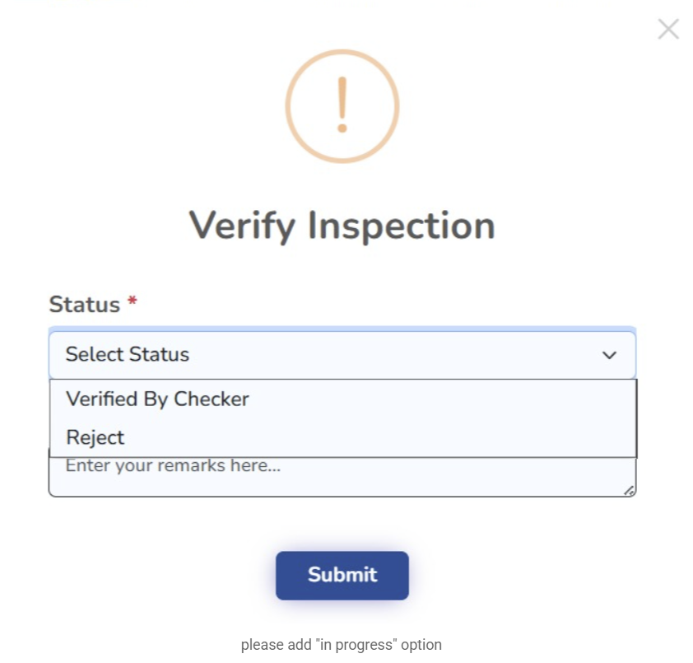
Enter and Verify Inspection by RO of Department and give their remarks
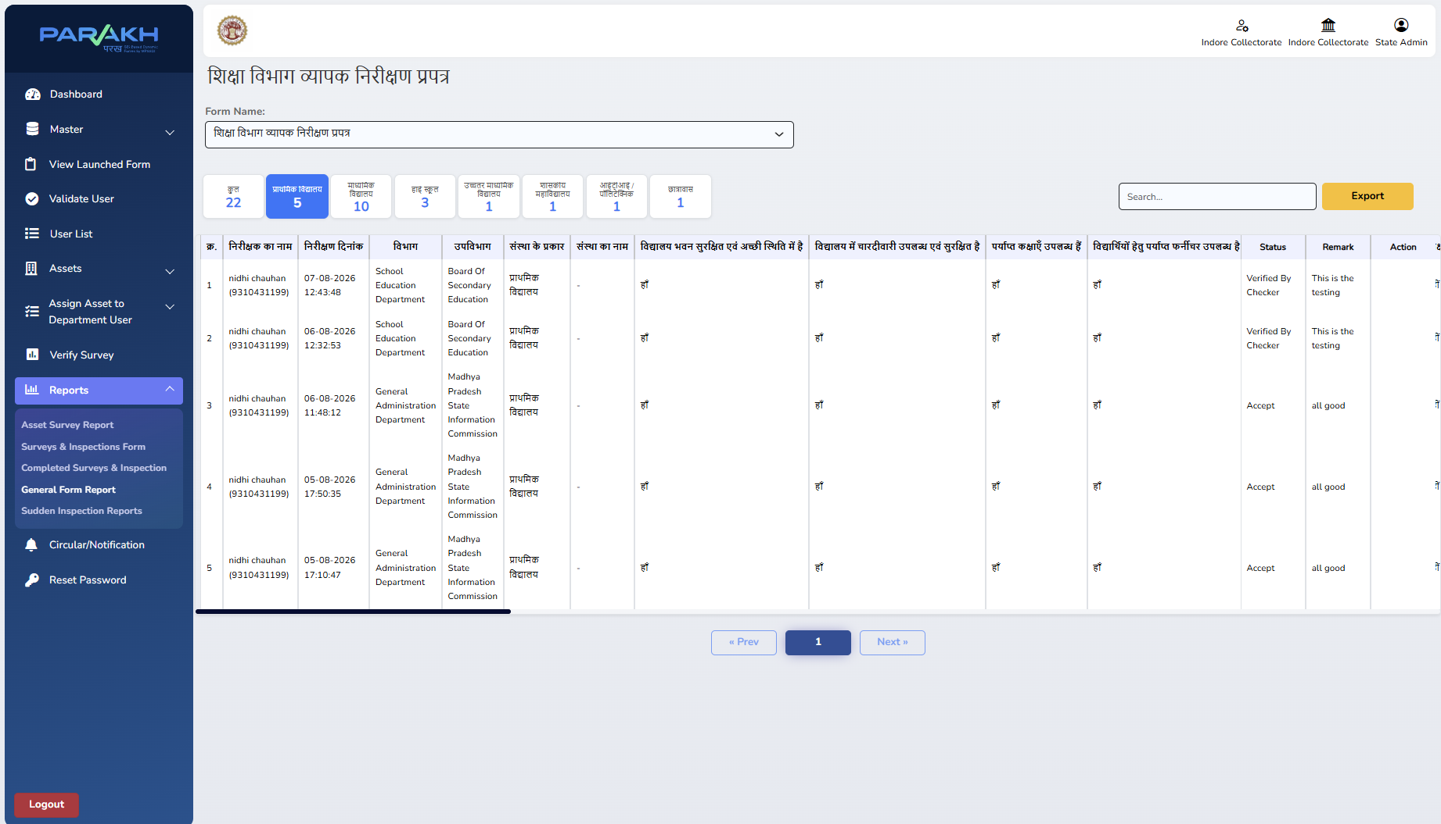
Elaborate details on this screen and also explain
about mention Status , Remark and Action
Step 12: Report Visible to Collector Sir's ID
Same General Form Report, viewed under the State Admin / Collector login
Suppose Nodal Officer right now created under Admin -
UserName - <<jc@123>>
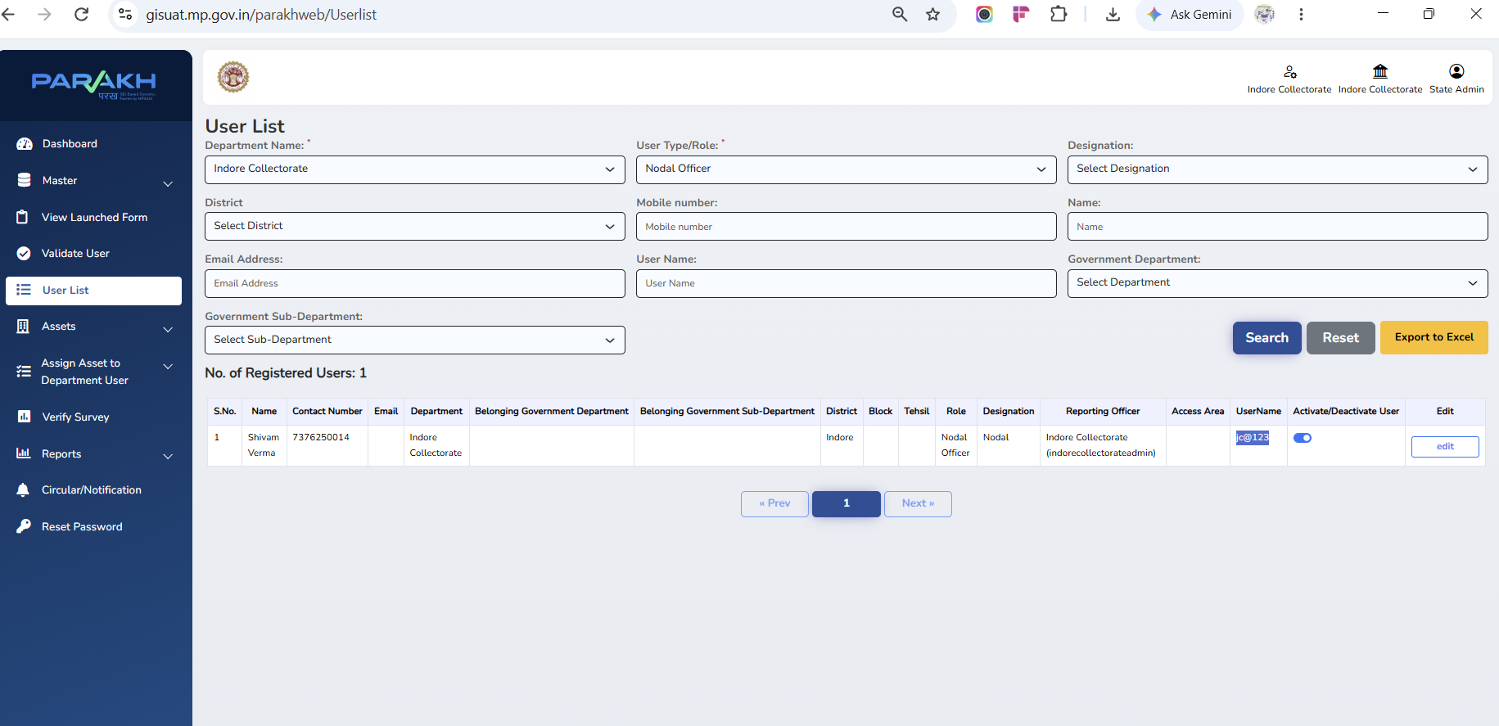

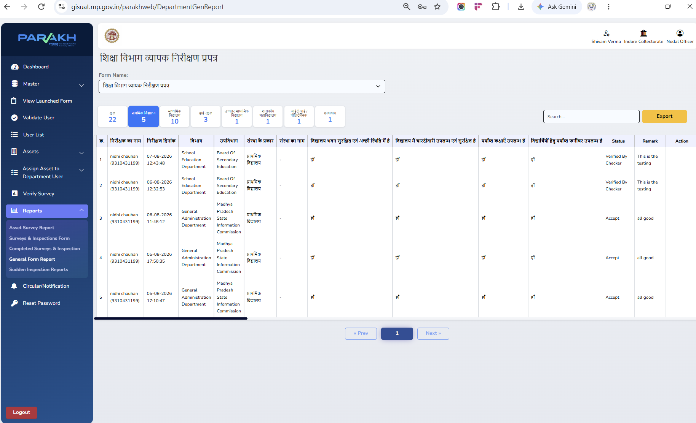
step 14:

Division-Level Review & Commissioner Dashboard
View-only dashboard for Divisional Commissioner Sir — build under way, targeted for completion next week
Scope of this module
- Aggregated, division-wide view of inspection data pulled in from every district under the division
- Read-only login being provisioned for the Divisional Commissioner Sir
- Compliance & status analytics, sliceable by district, department and inspection status
- Filters for department, district, date range and inspection status
- Fulfils SOP's final step — "Divisional Commissioner: View Dashboard & Division Monitoring"
Target completion: next week.
Dashboard build and division-level data rollup are currently in progress.
Will give Commissioner Sir a consolidated, real-time view across the full division.
Fulfils SOP's final 'Divisional Commissioner' review step.
Inspection Management System | District GIS · PARAKH
9

PHASE 2 : Divisional hierarchy & General form Report View to Divisional Officer -Commissioner

Step 14: Now Divisional hierarchy has Divisional level access and roles created
According to 11 divisions at Madhya Pradesh state level 11 divisions are available and
And each divisional hierarchy will have their respective districts and roles and credentikals such as
Username id : gov_indore_division --- Indore Division
And respective districts and departments under that division
Username id : gov_indore_district
Username id : gov_khargone_district
Username id : gov_khandwa_district
Username id : gov_jhabua_district
Username id : gov_barwani_district
Username id : gov_dhar_district
Username id : gov_burhanpur_district
Username id : gov_alirajpur_district

above all users created for division district role in developement enviroment

Step 15: Login over UAT or PROD environment of District GIS Parakh :

https://gisuat.mp.gov.in/parakhweb/
or
https://geoportal.mp.gov.in/parakhweb/
Login User name : <<gov_indore_division>>
Password: Test@123
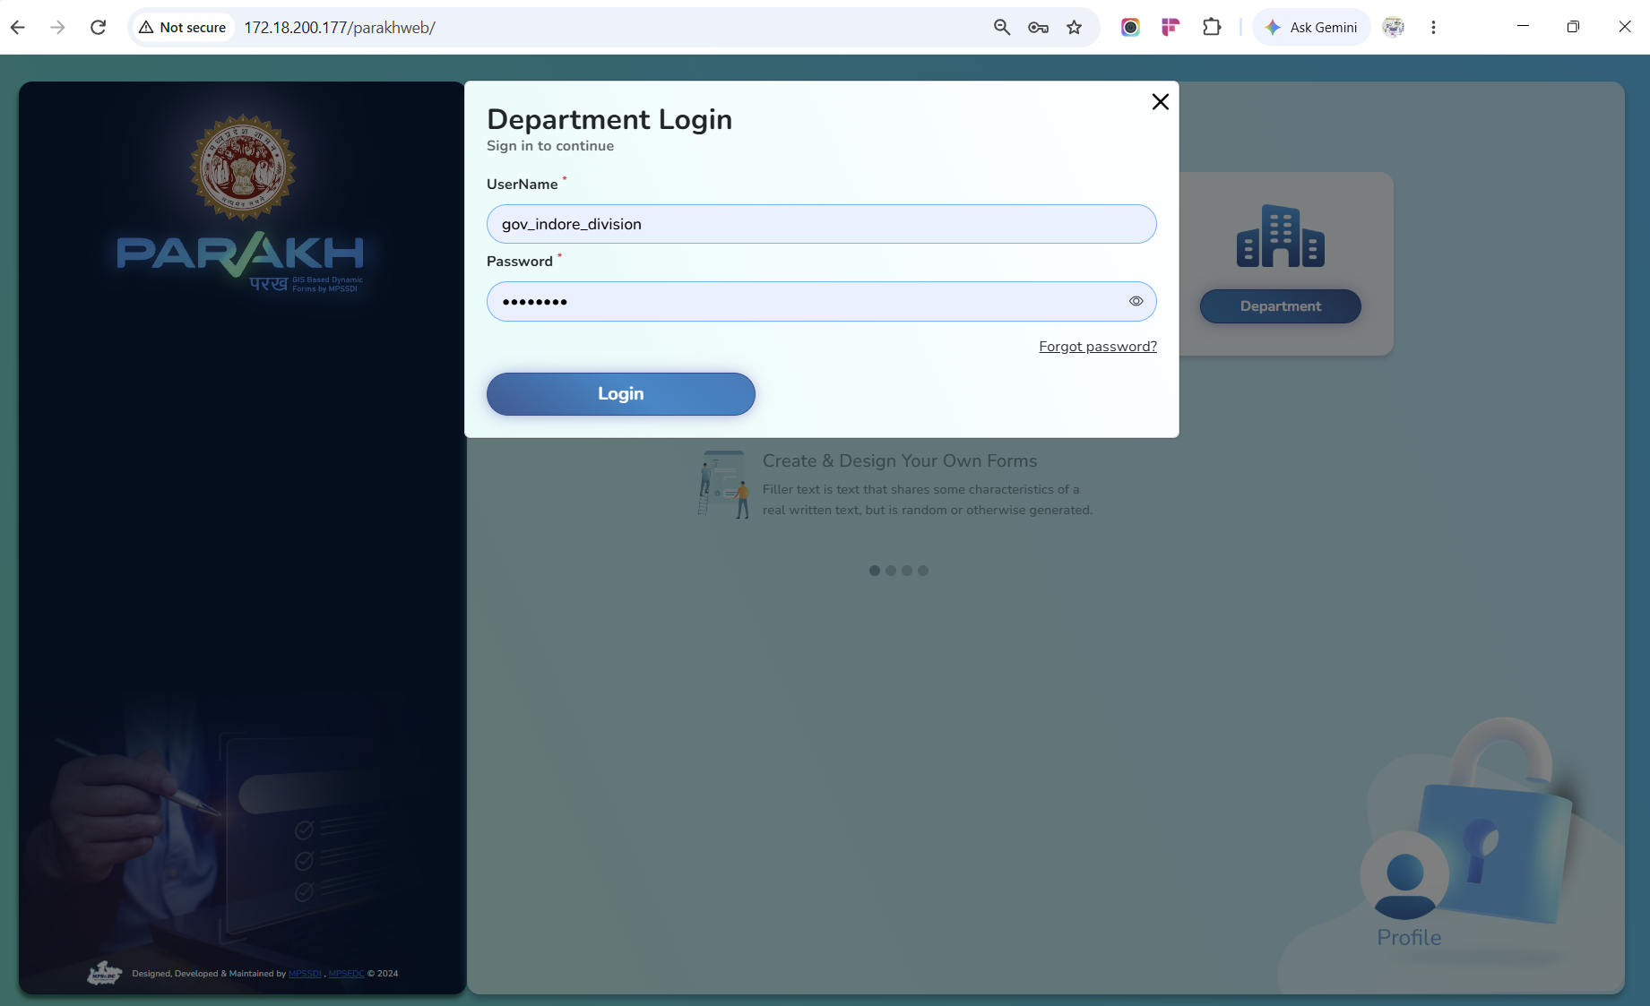
Step 15: Resepctive all under that division (divisional officer ) will be Viewed and seen
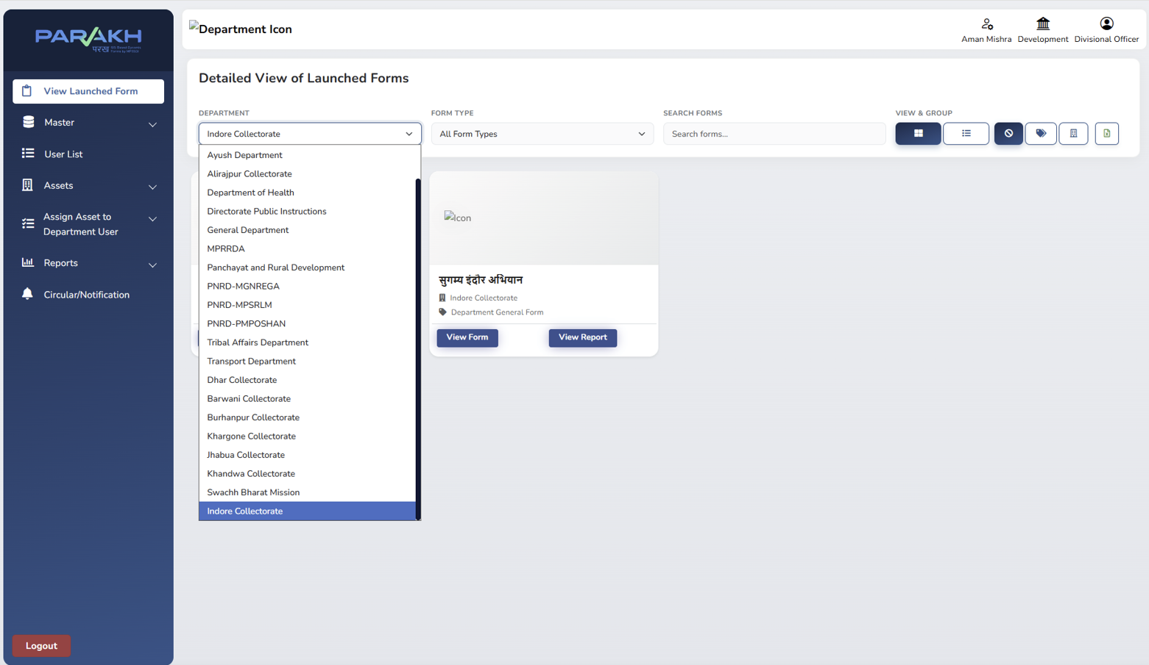
Step 16: Respective Users can be created under Master section for that division by divisional officer if required for specified districts department under that division

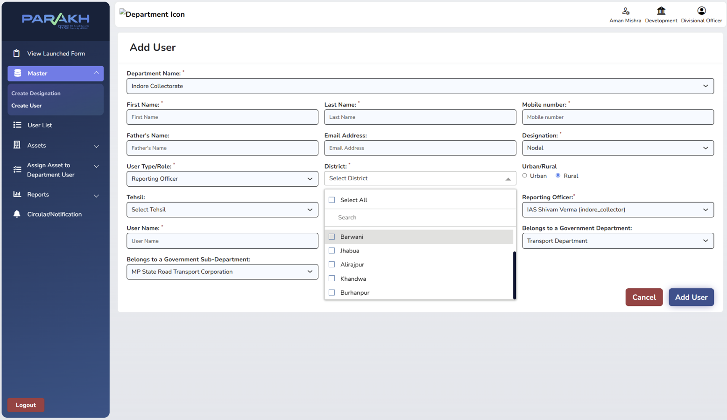

Step 17: User List for Department District and following Government Department & Sub Department for which inspection need to be conducted
Resepective collectorate Users created under that divisional officer
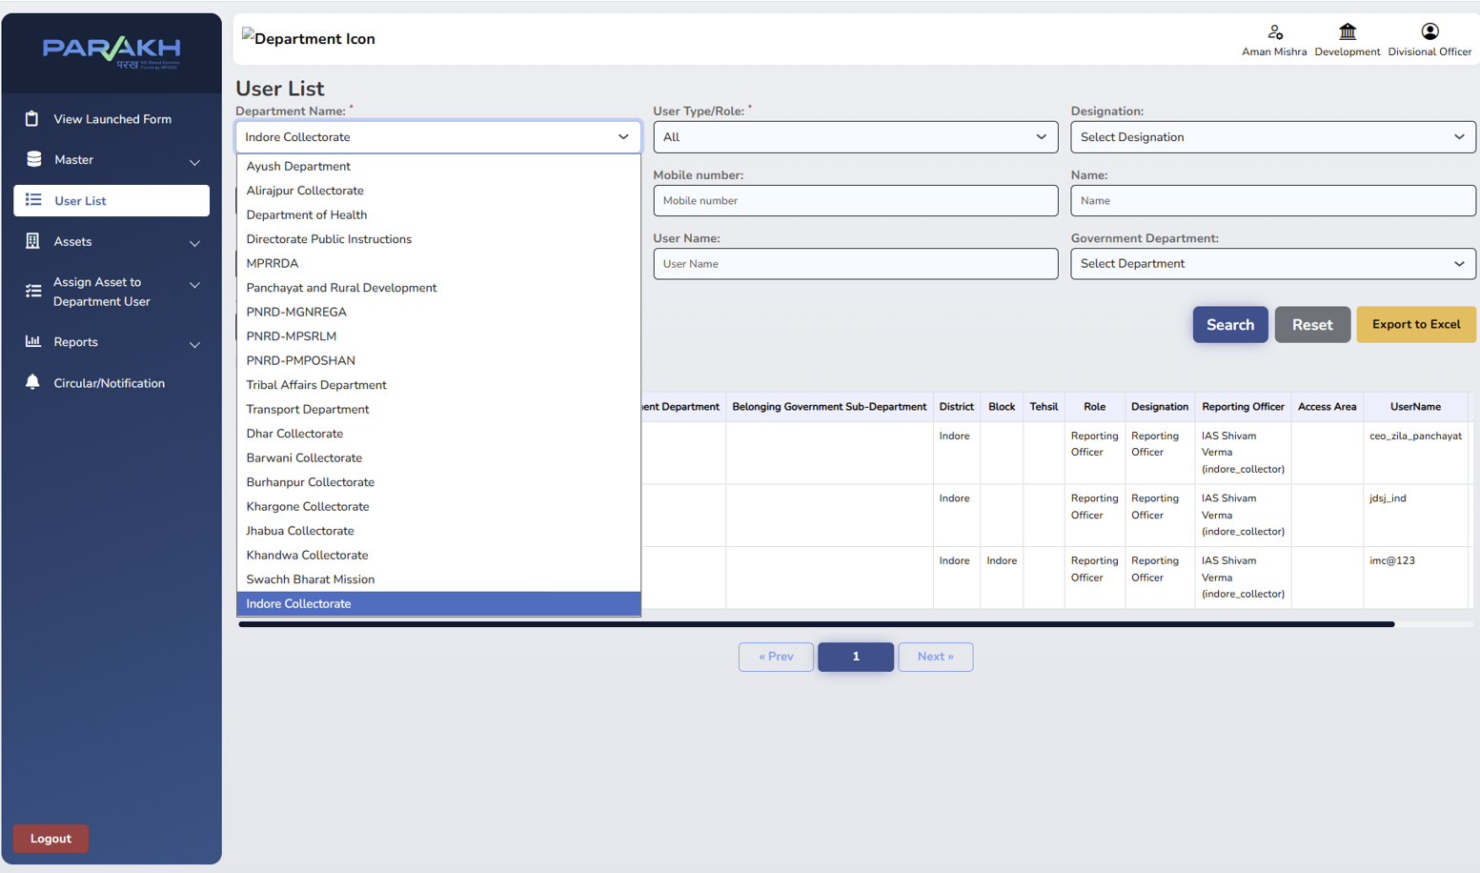
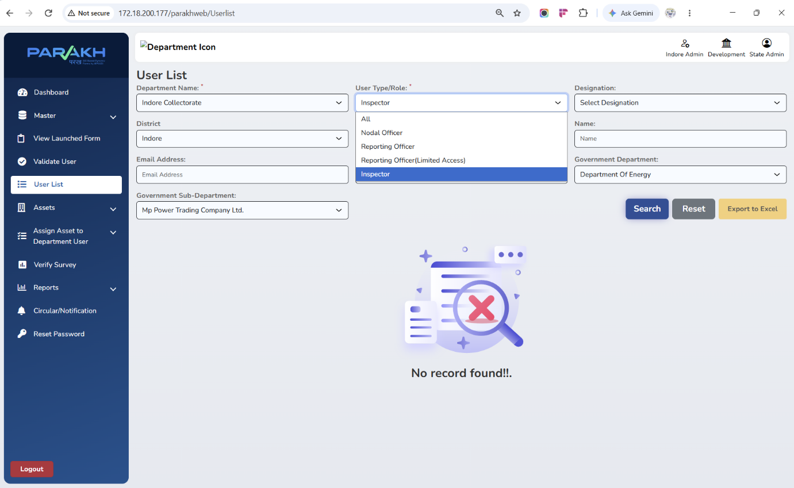

Step 18: As when required Asset list and Assign Asset added and assignment can be done under them 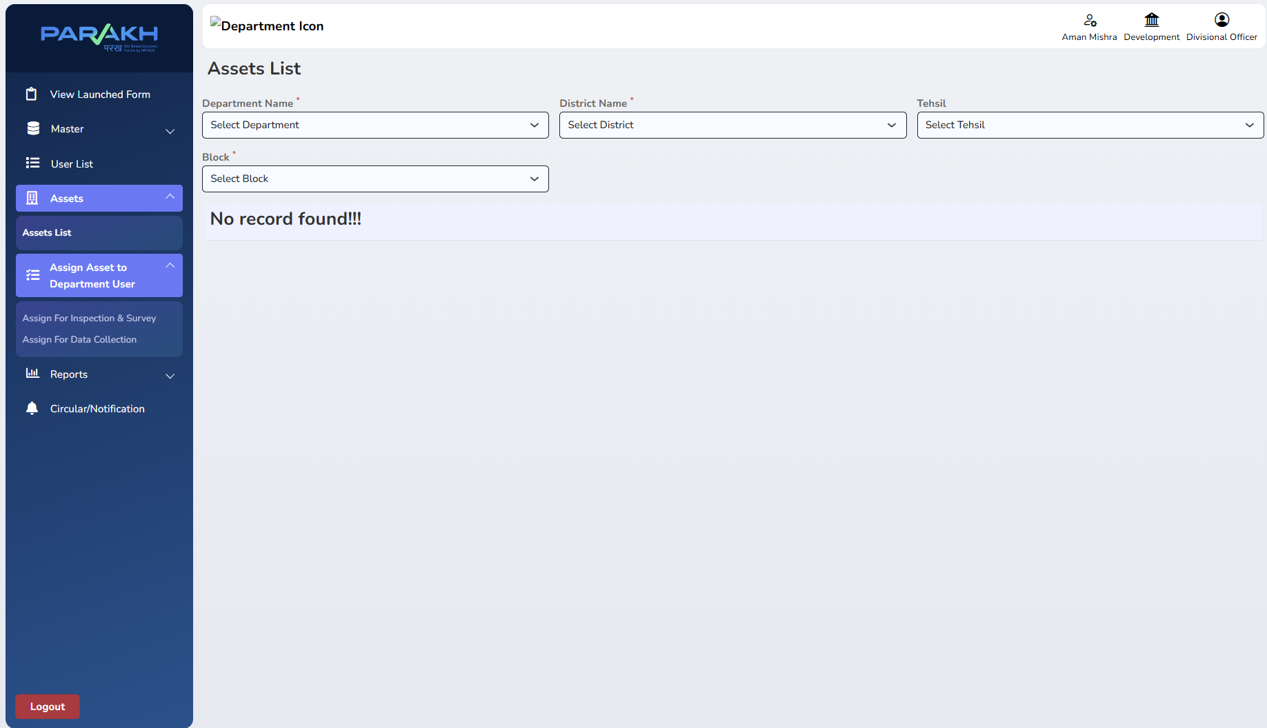
Step 19: Reports Section – Department General report form
view feature to Divisional Commissioner

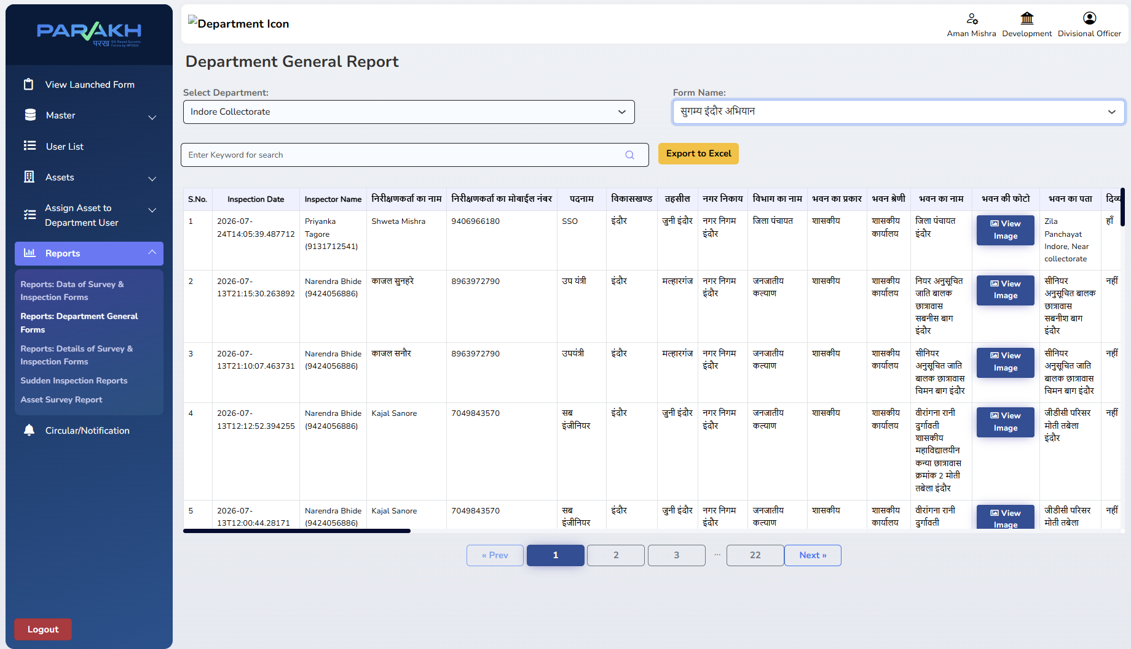

Step 20: Next Inspection needs to be conducted through Mobile App

Install Mobile APK – UAT environment – to be shared by team fro verification and validation purpose to be check inspection forms are working fine according to the requirement shared by the department
after uninstalling UAT then
Install PROD environment from – Google Play store – Android
Mobile Prod Live App to be used for inspection

